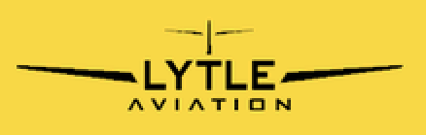
C-172M N12935 Revised: Dec 20th, 2022

PREFLIGHT
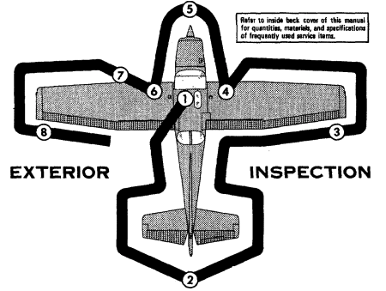
NOTE
Visually check aircraft for general condition during walkaround inspection. In cold weather, remove even small accumulations of frost, ice or snow from wing, tail, and control surface. Also, make sure that control surfaces contain no internal accumulation of ice or debris. If night flight is planned, check operation of all lights, and, make sure flashlight is available.
Cabin:

- Airworthiness and Registration- CHECK
- POH- CHECK
- Weight & Balance Sheet- CHECK
- Aircraft Key- ON FUEL SELECTOR
- Hobbs/Tach- VERIFY
- Headsets- PLUG IN
- Control Wheel Lock- REMOVE
- Controls- CHECK (free and correct)
- Ignition Switch- OFF
- Avionics Master Switch- OFF
- Prop- CLEAR- Visually
- Master Switch- ON
- Fuel Quantity Indicators- CHECK
- Flaps- EXTEND
- All Exterior Lights- ON
- Pitot Heat- ON
- Visually inspect lights
- Stall Warning Horn + Pitot Heat
- All Exterior Lights + Pitot Heat- OFF
- Master Switch- OFF
- Alternate Static- Check
- Mixture Control- IDLE CUTOFF
- Throttle- CLOSED
- Fuel Selector- BOTH
- Fire Extinguisher- CHECK (in green)
Aircraft General:
- Fuel- SUMP
- Fuel Level- CHECK
- Oil Level- CHECK (6-8 quarts)

Fuselage (Left side):
- Baggage Door- CHECK
- ELT Antenna- CHECK
- Left Fuselage- CHECK (dents, missing rivets, cracks…)
- Fuselage Lower Surface- CHECK
- Wing Upper Surface- CHECK

Empennage:
- Horizontal & Vertical Stabilizer- CHECK
- Elevator- CHECK
- Tail Tie-Down- DISCONNECT
- Rudder- CHECK
- VOR Antenna- CHECK
- Elevator Trim Tab- CHECK

Fuselage (Right side):
- Right Fuselage- CHECK (dents, missing rivets, cracks…)
- Fuselage Lower Surface- CHECK
- Wing Upper Surface- CHECK

Right Wing:
- Flap- CHECK
- Aileron- CHECK
- Wingtip- CHECK
- Wing Leading Edge- CHECK
- Air Vents- CHECK
- Wing Strut- CHECK
- Wing Tie-Down- DISCONNECT

Landing Gear (Right side):
- Strut- CHECK
- Tire/Wheel- CHECK
- Brakes/Brake Line- CHECK

Nose (Right side):
- Engine Cowling- CHECK
- Avionics Cooling Scoop- CHECK (if applicable)
- External Power Connection Port- CHECK (if applicable)
- Nose Wheel Steering Linkage- CHECK
- Shimmy Damper- CHECK
- Nose Wheel Strut- CHECK (minimum 3”)
- Tire- CHECK
- Exhaust- CHECK

Nose (front):
- Propeller- CHECK
- Spinner- CHECK
- Engine Air Inlets- CHECK
- Alternator Belt- CHECK
- Flywheel- CHECK
- Carburetor Air Filter- CHECK

Nose (Left side):
- Engine Cowling- CHECK
- Static Port- CHECK
- Avionics Cooling Scoop-
- Nose Wheel Steering Linkage- CHECK

Left Wing:
- Wing Strut- CHECK
- Air Vents- CHECK
- Wing Leading Edge- CHECK
- Pitot Tube- CHECK
- Fuel Tank Vent- CHECK
- Wing Tie Down- DISCONNECT
- Wingtip- CHECK
- Aileron- CHECK
- Flap- CHECK

Landing Gear (Left side):
- Strut- CHECK
- Tire/Wheel- CHECK
- Brakes/Brake Line- CHECK

Before Flight:
- Tie Downs- REMOVE
- Chocks- REMOVE
- Control Wheel Lock- REMOVE

P.A.V.E- Checklist
- Pilot
- Aircraft
- EnVironment
- External pressures

If Leaving the Airplane:
- Control Wheel Lock- IN
- Sunshade installed
- Doors- Closed
- Tie Downs- TIED (if windy)
- Chocks- INSERT

